Problem 1: Cache Access-Time & Performance

Ben is trying to determine the best cache configuration for a new processor. He knows how to build two kinds of caches: direct-mapped caches and 4-way set-associative caches. The goal is to find the better cache configuration with the given building blocks. He wants to know how these two different configurations affect the clock speed and the cache miss-rate, and choose the one that provides better performance in terms of average latency for a load.

Problem 1.A | Access Time: Direct-Mapped

Now we want to compute the access time of a direct-mapped cache. We use the implementation shown in Figure 1. Assume a 128-KB cache with 8-word (32-byte) cache lines. The address is 32 bits and byte-addressed, so the two least significant bits of the address are ignored since a cache access is word-aligned. The data output is also 32 bits (1 word), and the MUX selects one word out of the eight words in a cache line. Using the delay equations given in Table 2.1-1, fill in the column for the direct-mapped (DM) cache in the table. In the equation for the data output driver, ‘associativity’ refers to the associativity of the cache (1 for direct-mapped caches, A for A-way set-associative caches).
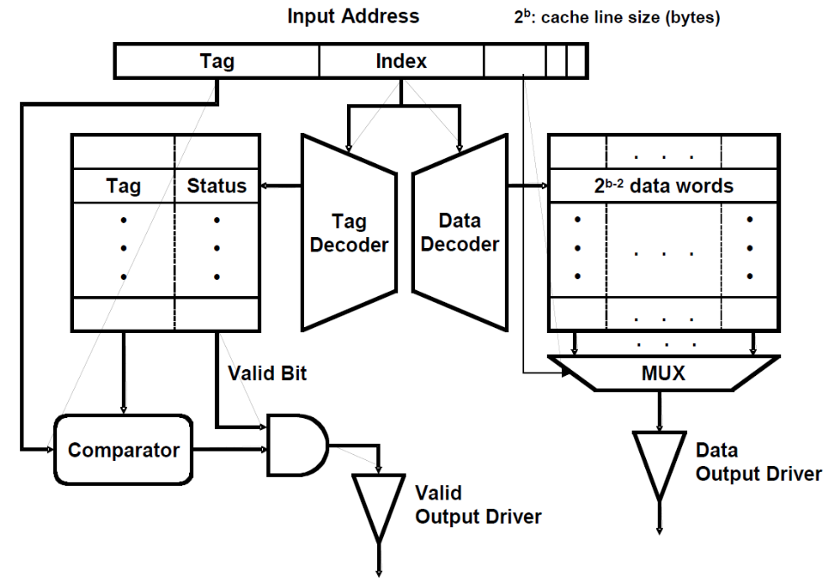

Figure 1 A direct-mapped cache implementation

Component | Delay equation (ps) |  | DM (ps) | SA (ps)
Decoder | 20×(# of index bits) + 100 | Tag | 340 | 300
Decoder | 20×(# of index bits) + 100 | Data | 340 | 300
Memory array | 20× log₂ (# of rows) +  20× log₂ (# of bits in a row) + 100 | Tag | 422 | 425
Memory array | 20× log₂ (# of rows) +  20× log₂ (# of bits in a row) + 100 | Data | 500 | 500
Comparator | 20×(# of tag bits) + 100 |  | 400 | 440
N-to-1 MUX | 50×log₂ N + 100 |  | 250 | 250
Buffer driver | 200 |  |  | 200
Data output driver | 50×(associativity) + 100 |  | 150 | 300
Valid output driver | 100 |  | 100 | 100

Table 2.1-1: Delay of each Cache Component

What is the critical path of this direct-mapped cache for a cache read? What is the access time of the cache (the delay of the critical path)? To compute the access time, assume that a 2-input gate (AND, OR) delay is 50 ps. If the CPU clock is 1.5 GHz, how many CPU cycles does a cache access take?

Index = 12bits, Tag = 32-2-3-12=15bits
从访问到tag output driver输出耗时：
T1 = 340 + 422 + 400 + 50 + 100 = 1312ps
从访问到data output driver输出耗时：
T2 = 340 + 500 + 250 + 150 = 1240ps
由于T1>T2，所以主要路径是Input address -> Tag Decoder -> Tag Memory -> Comparator -> AND gate -> Valid output driver
访问时间t = 1312ps，在1.5GHz的时钟下，需要的时钟周期数：
cycles = 1.312*1.5 = 1.968 ≈ 2

Problem 1.B | Access Time: Set-Associative

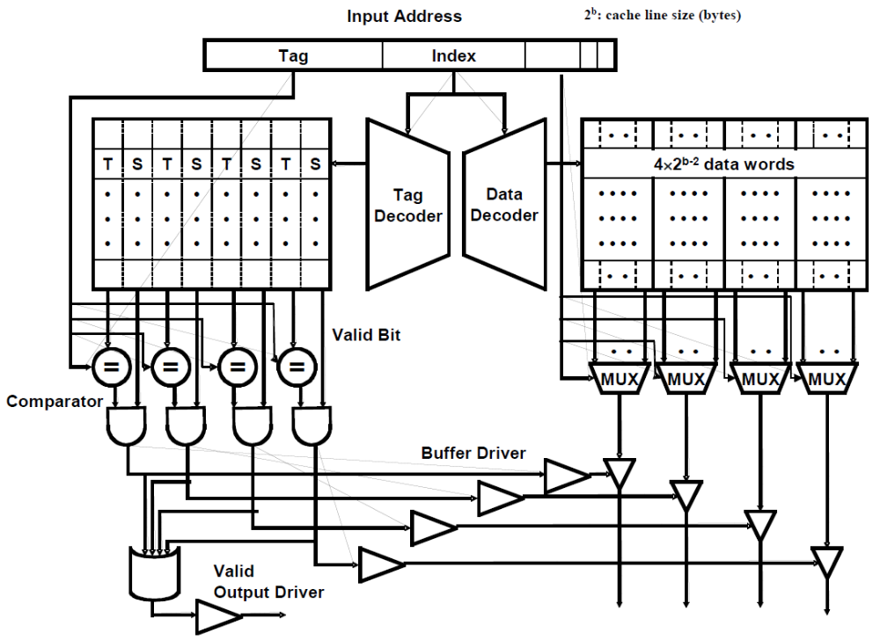
Figure 2 A 4-way set-associative cache implementation
We also want to investigate the access time of a set-associative cache using the 4-way set-associative cache in Figure 2. Assume the total cache size is still 128-KB (each way is 32-byes), a 4-input gate delay is 100 ps, and all other parameters (such as the input address, cache line, etc.) are the same as part 2.1.A. Compute the delay of each component, and fill in the column for a 4-way set-associative cache in Table 2.1-1.

bits in a row = (17+2)*4 = 76
Decoder(Tag) = 20*10+100 = 300ps
Decoder(Data) = 20*10 +100 = 300ps
Memory array(Tag) = 20*10+20*log₂(76)+100 = 425ps
Comparator = 20*17+100 = 440ps
N-to1 MUX = 50*3+100 = 250ps
Data output driver = 50*4+100 = 300ps

What is the critical path of the 4-way set-associative cache? What is the access time of the cache (the delay of the critical path)? What is the main reason that the 4-way set-associative cache is slower than the direct-mapped cache? If the CPU clock is 1.5 GHz, how many CPU cycles does a cache access take?

从tag memory到valid output driver输出耗时：
T1 = 300 + 425 + 440 + 50 + 100 + 100 = 1415ps
从tag memory经过buffer到data output driver输出耗时：
T2 = 300 + 425 + 440 + 50 + 200 + 300 = 1715ps
从data memory到data output driver输出耗时：
T3 = 300 + 500 + 250 + 300 = 1350ps
由于T2>T1>T3，所以主要路径是Input address -> Tag Decoder -> Tag Memory -> Comparator -> 2-input AND -> Buffer Driver -> data output driver.
访问时间t = 1715ps，在1.5GHz时钟频率下所需周期数：
cycles = 1.715*1.5 = 2.5725 ≈ 3
四路组相联比直接映射慢的原因是data output driver需要根据比较器比较的结果决定是哪个作为数据输出。

Problem 1.C | Miss-rate analysis

Now Ben is studying the effect of set-associativity on the cache performance. Since he now knows the access time of each configuration, he wants to know the miss-rate of each one. For the miss-rate analysis, Ben is considering two small caches: a direct-mapped cache with 8 lines with 16 bytes/line, and a 4-way set-associative cache of the same size and line size. For the set-associative cache, Ben tries out two replacement policies – least recently used (LRU) and round robin (FIFO).

Ben tests the cache by accessing the following sequence of hexadecimal byte addresses, starting with empty caches. For simplicity, assume that the addresses are only 12 bits. Complete the following tables for the direct-mapped cache and both types of 4-way set-associative caches showing the progression of cache contents as accesses occur (in the tables, ‘inv’ = invalid, and the column of a particular cache line contains the tag of that line). Also, for each address calculate the tag and index (which should
help in filling out the table). You only need to fill in elements in the table when a value changes.

D-map  Address | Addresses and tags are in HEX
D-map  Address | line in cache (tag) |  |  |  |  |  |  |  | hit?
D-map  Address | L0 | L1 | L2 | L3 | L4 | L5 | L6 | L7
110 | inv | 2 | inv | inv | inv | inv | inv | inv | no
136 |  |  |  | 2 |  |  |  |  | no
202 | 4 |  |  |  |  |  |  |  | no
1A3 |  |  | 3 |  |  |  |  |  | no
102 | 2 |  |  |  |  |  |  |  | no
361 |  |  |  |  |  |  | 6 |  | no
204 | 4 |  |  |  |  |  |  |  | no
114 |  | 2 |  |  |  |  |  |  | yes
1A4 |  |  | 3 |  |  |  |  |  | yes
177 |  |  |  |  |  |  |  | 2 | no
301 | 6 |  |  |  |  |  |  |  | no
206 | 4 |  |  |  |  |  |  |  | no
135 |  |  |  | 2 |  |  |  |  | yes

 | D-map
Total Misses | 10
Total Accesses | 13

4-way  Address | LRU -- addresses and tags are in HEX
4-way  Address | line in cache |  |  |  |  |  |  |  | hit?
4-way  Address | Set 0 |  |  |  | Set 1 |  |  |  | hit?
4-way  Address | way0 | way1 | Way2 | way3 | way0 | way1 | way2 | way3
110 | Inv | Inv | Inv | inv | 8 | inv | inv | inv | no
136 |  |  |  |  |  | 9 |  |  | no
202 | 10 |  |  |  |  |  |  |  | no
1A3 |  | 0D |  |  |  |  |  |  | no
102 |  |  | 08 |  |  |  |  |  | no
361 |  |  |  | 1B |  |  |  |  | no
204 | 10 |  |  |  |  |  |  |  | yes
114 |  |  |  |  | 08 |  |  |  | yes
1A4 |  | 0D |  |  |  |  |  |  | yes
177 |  |  |  |  |  |  | 0B |  | no
301 |  |  | 18 |  |  |  |  |  | no
206 | 10 |  |  |  |  |  |  |  | yes
135 |  |  |  |  |  | 09 |  |  | yes

 | 4-way LRU
Total Misses | 8
Total Accesses | 13

4-way  Address | FIFO -- addresses and tags are in HEX
4-way  Address | line in cache (tag) |  |  |  |  |  |  |  | hit?
4-way  Address | Set 0 |  |  |  | Set 1 |  |  |  | hit?
4-way  Address | way0 | way1 | way2 | way3 | way0 | way1 | way2 | way3
110 | inv | inv | inv | inv | 8 | inv | inv | inv | no
136 |  |  |  |  |  | 9 |  |  | no
202 | 10 |  |  |  |  |  |  |  | no
1A3 |  | 0D |  |  |  |  |  |  | no
102 |  |  | 08 |  |  |  |  |  | no
361 |  |  |  | 1B |  |  |  |  | no
204 | 10 |  |  |  |  |  |  |  | yes
114 |  |  |  |  | 08 |  |  |  | yes
1A4 |  | 0D |  |  |  |  |  |  | yes
177 |  |  |  |  |  |  | 0B |  | no
301 | 18 |  |  |  |  |  |  |  | no
206 |  | 10 |  |  |  |  |  |  | no
135 |  |  |  |  |  | 09 |  |  | yes

 | 4-way FIFO
Total Misses | 9
Total Accesses | 13

Problem 1.D | Average Latency

Assume that the results of the above analysis can represent the average miss-rates of the direct-mapped and the 4-way set-associative 128-KB caches studied in 1.A and 1.B. What would be the average memory access latency in CPU cycles for each cache (assume that the cache miss penalty is 20 cycles)? Which one is better? For the different replacement policies for the set-associative cache, which one has a smaller cache miss rate for the address stream in 1.C? Explain why. Is that replacement policy always going to yield better miss rates? If not, give a counter example using an address stream.

对于直接映射而言：
AMAT = 2 + (10/13)*20 = 17.38 ≈ 18 cycles
对于使用LRU的4路组相联而言：
AMAT = 3 + (8/13)*20 = 15.31 ≈ 16 cycles
所以组相联方式平均访问延迟比直接映射更优
LRU比FIFO有更低的miss rate，因为LRU偏向于不用就被更换，是更贴切使用频率的，而FIFO并不区分这种，不由分说地只靠空间上的偏移，所以在程序中FIFO的miss rate会更低。
但LRU不是总优于FIFO，比如在有3行的全相联中，按顺序访问1，2，3，1，4，5，3时，LRU miss rate = 6/7，FIFO miss rate = 5/7，此时FIFO比LRU更优。

Problem 2: Loop Ordering

This problem evaluates the cache performances for different loop orderings. You are asked to consider the following two loops, written in C, which calculate the sum of the entries in a 128 by 32 matrix of 32-bit integers:

Loop A | Loop B
sum = 0;  for (i = 0; i < 128; i++)  for (j = 0; j < 32; j++)  sum += A[i][j]; | sum = 0;  for (j = 0; j < 32; j++)  for (i = 0; i < 128; i++)  sum += A[i][j];

The matrix A is stored contiguously in memory in row-major order. Row major order means that elements in the same row of the matrix are adjacent in memory as shown in the following memory layout:

A[i][j] resides in memory location [4*(32*i + j)]

Memory Location:

0 | 4 |  |  | 124 | 128 |  | 4*(32*127+31)
A[0][0] | A[0][1] |  | ... | A[0][31] | A[1][0] | ... | A[127][31]

For Problem 2.A to Problem 2.C, assume that the caches are initially empty. Also, assume that only accesses to matrix A cause memory references and all other necessary variables are stored in registers. Instructions are in a separate instruction cache.

Problem 2.A

Consider a 4KB direct-mapped data cache with 8-word (32-byte) cache lines.
Calculate the number of cache misses that will occur when running Loop A.
Calculate the number of cache misses that will occur when running Loop B.

The number of cache misses for Loop A:_128*(32/8)=512__________________

The number of cache misses for Loop B:_32*128=4096_________________________

Problem 2.B

Consider a direct-mapped data cache with 8-word (32-byte) cache lines. Calculate the minimum number of cache lines required for the data cache if Loop A is to run without any cache misses other than compulsory misses. Calculate the minimum number of cache lines required for the data cache if Loop B is to run without any cache misses other than compulsory misses.

Data-cache size required for Loop A: ___1_________________________ cache line(s)

Data-cache size required for Loop B: ___1024______________________ cache line(s)

Problem 2.C

Consider a 4KB fully-associative data cache with 8-word (32-byte) cache lines. This data cache uses a first-in/first-out (FIFO) replacement policy.
Calculate the number of cache misses that will occur when running Loop A.
Calculate the number of cache misses that will occur when running Loop B.

The number of cache misses for Loop A:__512_________________________

The number of cache misses for Loop B:__512_________________________

Problem 3: Microtagged Cache

In this problem, we explore microtagging, a technique to reduce the access time of set-associative caches. Recall that for associative caches, the tag check must be completed before load results are returned to the CPU, because the result of the tag check determines which cache way is selected. Consequently, the tag check is often on the critical path.

The time to perform the tag check (and, thus, way selection) is determined in large part by the size of the tag. We can speed up way selection by checking only a subset of the tag—called a microtag—and using the results of this comparison to select the appropriate cache way. Of course, the full tag check must also occur to determine if the cache access is a hit or a miss, but this comparison proceeds in parallel with way selection. We store the full tags separately from the microtag array.

We will consider the impact of microtagging on a 4-way set-associative 16KB data cache with 32-byte lines. Addresses are 32 bits long. Microtags are 8 bits long. The baseline cache (i.e. without microtagging) is depicted in Figure 2. Figure 3, below, shows the modified tag comparison and driver hardware in the microtagged cache.

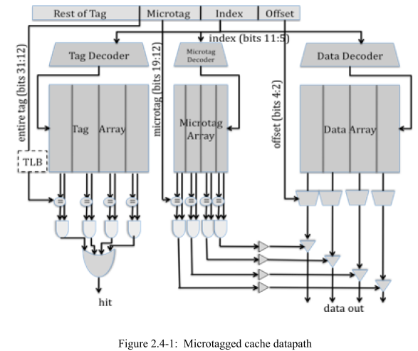
Figure 3 Microtagged Cache

Problem 3.A | Cache Cycle Time

Table 2.4-1, below, contains the delays of the components within the 4-way set-associative cache, for both the baseline and the microtagged cache. For both configurations, determine the critical path and the cache access time (i.e., the delay through the critical path). Fill in the columns for the microtagged cache.

Assume that the 2-input AND gates have a 50ps delay and the 4-input OR gate has a 100ps delay.

Component | Delay equation (ps) |  | Baseline | Microtagged
Decoder | 20×(# of index bits) + 100 | Tag | 240 | 240
Decoder | 20×(# of index bits) + 100 | Data | 240 | 240
Memory array | 20×log₂ (# of rows) +  20×log₂ (# of bits in a row) + 100 | Tag | 369 | 330
Memory array | 20×log₂ (# of rows) +  20×log₂ (# of bits in a row) + 100 | Data | 440 | 440
Memory array | 20×log₂ (# of rows) +  20×log₂ (# of bits in a row) + 100 | Microtag |  | 306
Comparator | 20×(# of tag bits) + 100 | Tag | 500 | 500
Comparator | 20×(# of tag bits) + 100 | Microtag |  | 260
N-to-1 MUX | 50×log₂ N + 100 |  | 250 | 250
Buffer driver | 200 |  | 200 | 200
Data output driver | 50×(associativity) + 100 |  | 300 | 300
Valid output driver | 100 |  | 100 | 100

Table 2.4-1: Delay of each Cache Component

What is the old critical path? The old cycle time (in ps)?
老路径是关键路径：Input address -> Tag Decoder -> Tag Memory -> Comparator -> 2-input AND -> Buffer Driver -> data output driver.
时间延迟：t = 240 + 330 + 500 + 50 + 200 + 300 = 1620 ps

What is the new critical path? The new cycle time (in ps)?
经过Tag Decoder的耗时：
T1 = 240 + 330 + 500 + 50 + 100 + 100 = 1320 ps
从microtag到buffer driver耗时：
T21 = 240 + 306 + 260 + 50 + 200 = 1056 ps
从data到data output driver:
T22 = 240 + 440 + 250 = 930 ps
所以数据输出耗时：
T2 = 1056 + 300 = 1356 ps
所以关键路径为Microtag Decoder -> Microtag Array -> Comparator -> 2-input AND -> buffer driver -> data output driver.
访问时间为t = 1356 ps

Problem 3.B | AMAT
Assume temporarily that both the baseline cache and the microtagged cache have the same hit rate, 95%, and the same average miss penalty, 20 ns. Using the cycle times computed in 3.A as the hit times, compute the average memory access time for both caches. What was the old AMAT (in ns)? What is the new AMAT (in ns)?

AMAT_old = 1.62 + 1 = 2.62 ns
AMAT_new = 1.356 + 1 = 2.356 ns

Problem 3.C | Constraints

Microtags add an additional constraint to the cache: in a given cache set, all microtags must be unique. This constraint is necessary to avoid multiple microtag matches in the same set, which would prevent the cache from selecting the correct way.

State which of the 3C’s of cache misses this constraint affects. How will the cache miss rate compare to an ordinary 4-way set-associative cache? How will it compare to that of a direct-mapped cache of the same size?
这个Microtag的方式会增加conflict missing，相比传统的四路组相联，这个方法会有额外的限制，效果会更差，但不会比直接映射差，因为对于有相同的microtag和set的两个cache行，也同样会index到相同的行，减少microtag的相联数可以减少conflict missing。

Problem 4: Victim Cache Evaluation

Although direct-mapped caches have an advantage of smaller access time than set- associative caches, they have more conflict misses due to their lack of associativity. In order to reduce these conflict misses, Norm Jouppi proposed victim caching, where a small fully-associative back up cache, called a victim cache, is added to a direct-mapped L1 cache to hold recently evicted cache lines.

The following diagram shows how a victim cache can be added to a direct-mapped L1 data cache. Upon a data access, the following chain of events takes place:

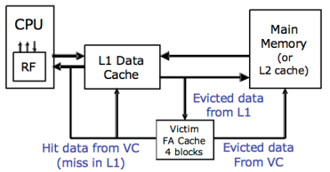

- The L1 data cache is checked. If it holds the data requested, the data is returned.
- If the data is not in the L1 cache, the victim cache is checked. If it holds the data requested, the data is moved into the L1 cache and sent back to the processor. The data evicted from the L1 cache is put in the victim cache, and put at the end of the FIFO replacement queue.
- If neither of the caches holds the data, it is retrieved from memory, and put in the L1 cache. If the L1 cache needs to evict old data to make space for the new data, the old data is put in the victim cache and placed at the end of the FIFO replacement queue. Any data that needs to be evicted from the victim cache to make space is written back to memory or discarded, if unmodified.

Note that the two caches are exclusive. That means that the same data cannot be stored in both L1 and victim caches at the same time.

Problem 4.A | Baseline Cache Design

The diagram below shows our victim cache, a 32-Byte fully associative cache with four 8-Byte cache lines. Each line contains of two 4-Byte words and has an associated tag and two status bits (valid and dirty). The Input Address is 32-bits and the two least significant bits are assumed to be zero. The output of the cache is a 32-bit word.

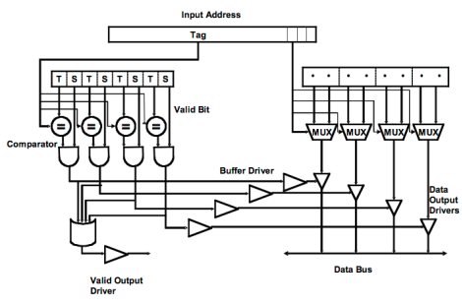
Figure 4: Victim cache datapath

Please complete Table 2.5-1 with delays across each element of the cache. Using the data you compute in Table 2.5-1, calculate the critical path delay through this cache (from when the Input Address is set to when both Valid Output Driver and the appropriate Data Output Driver are outputting valid data).

Component | Delay equation (ps) | FA(ps)
Comparator | 20×(# of tag bits) + 100 | 680
N-to-1 MUX | 50×log₂ N + 100 | 150
Buffer driver | 200 | 200
AND gate | 100 | 100
OR gate | 50× log₂ N + 100 | 200
Data output driver | 50×(associativity) + 100 | 300
Valid output driver | 100 | 100
Table 2.5-1: Delay of each cache component

Critical Path Cache Delay:
从input address到valid output driver输出耗时：
T1 = 680 + 100 +200 +100 = 1080 ps
从input address到data output driver输出耗时：
T2 = 680 + 100 + 200 +300 = 1280 ps
所以关键路径为input address -> valid bit -> buffer driver -> data output driver。
Critical Path Cache Delay: t = 1280 ps

Problem 4.B | Victim Cache Behavior

Now we will study the impact of a victim cache on cache hit rate. Our main L1 cache is a 128 byte, direct-mapped cache with 16 bytes per cache line. The cache is word (4-bytes) addressable. The victim cache in Figure 4 is a 32-byte fully associative cache with 16 bytes per cache line, and is also word addressable. The victim cache uses the first in first out (FIFO) replacement policy.

Please complete Table 2.5-2 showing a trace of memory accesses. In the table, each entry contains the tag of that line, or “inv”, if no data is present. You should only fill in elements in the table when a value changes. For simplicity, the addresses are only 8 bits. The first 3 lines of the table have been filled in for you. For your convenience, the address breakdown for access to the main cache is depicted below.
Input Address | Main Cache (tag) |  |  |  |  |  |  |  |  | Victim Cache (tag)
 | L0 | L1 | L2 | L3 | L4 | L5 | L6 | L7 | Hit? | Way0 | Way1 | Hit?
 | inv | inv | inv | inv | inv | inv | inv | inv | - | inv | inv | -
0 | 0 |  |  |  |  |  |  |  | N |  |  | N
80 | 1 |  |  |  |  |  |  |  | N | 0 |  | N
4 | 0 |  |  |  |  |  |  |  | N | 8 |  | Y
A0 |  |  | 1 |  |  |  |  |  | N |  |  | N
10 |  | 0 |  |  |  |  |  |  | N |  |  | N
C0 |  |  |  |  | 1 |  |  |  | N |  |  | N
18 |  | 0 |  |  |  |  |  |  | Y
20 |  |  | 0 |  |  |  |  |  | N |  | A | N
8C | 1 |  |  |  |  |  |  |  | N | 0 |  | Y
28 |  |  | 0 |  |  |  |  |  | Y
AC |  |  | 1 |  |  |  |  |  | N |  | 2 | Y
38 |  |  |  | 0 |  |  |  |  | N |  |  | N
C4 |  |  |  |  | 1 |  |  |  | Y
3C |  |  |  | 0 |  |  |  |  | Y
48 |  |  |  |  | 0 |  |  |  | N | C |  | N
0C | 0 |  |  |  |  |  |  |  | N |  | 8 | N
24 |  |  | 0 |  |  |  |  |  | N | A |  | N
Table 2.5-2: Memory access trace

Problem 4.C | Average Memory Access Time

Assume 15% of memory accesses are resolved in the victim cache. If retrieving data from the victim cache takes 5 cycles and retrieving data from main memory takes 55 cycles, by how many cycles does the victim cache improve the average memory access time?

the average memory access time improvement:
0.15*(55-5) = 7.5 cycles.
Problem 5: Three C’s of Cache Misses

Mark whether the following modifications will cause each of the categories to increase, decrease, or whether the modification will have no effect. You can assume the baseline cache is set associative. Explain your reasoning.

 | Compulsory Misses | Conflict Misses | Capacity Misses
Double the associativity  (capacity and line size constant) | No effect.  数据不在cache中，增加associativity并不影响Compulsory miss | Decrease.  因为增加associativity能够增加cache存放相同set的空间，从而减少conflict miss | No effect.  增加associativity并不影响存储容量
Halving the line size  (associativity and  # sets constant) | Increase.  更短的line size会减弱cache的spatial locality，也即每个line能存的数据减少，从而增加了compulsory miss. | Increase.  每个set存储的空间较少了 | Increase.  整体cache存储容量减小
Doubling the number of sets  (capacity and line size constant) | No effect.  如果数据不在cache中，增加组数并不影响compulsory miss. | Increase.  因为associativity减小了，对于每个set来说，空间减小，更容易发生conflict miss. | No effect.  增加组数不影响cache存储容量

 | Compulsory Misses | Conflict Misses | Capacity Misses
Adding prefetching | Decrease.  prefetch可以提前将数据放入cache中，在访问时能够找到，减小compulsory miss。 | Increase.  prefetch的数据容易对原本的cache产生影响，是数据改变，造成conflict miss。  No effect.  添加stream buffers的话就不会有影响 | Increase.  prefetch的数据对原本cache造成影响，可能导致capacity miss。  No effect.  添加stream buffers的话就不会有影响

Problem 6: Memory Hierarchy Performance

Mark whether the following modifications will cause each of the categories to increase, decrease, or whether the modification will have no effect. You can assume the baseline cache is set associative. Explain your reasoning.

 | Hit Time | Miss Rate | Miss Penalty
Double the associativity  (capacity and line size constant) | Increase.  增加associativity，tag会变大，比对tag的时间变长，hit time增加 | Decrease.  能够有效减少conflict miss，从而降低miss rate. | No effect.  不影响miss发生之后后级memory的访问时间
Halving the line size  (associativity and  # sets constant) | Decrease.  cache存储容量减少，hit time减小 | Increase.  cache容量减小，空间本地化程度减弱，会发生更多的miss | Decrease.  向后级memory所需的带宽降低，访问速度变快
Doubling the number of sets  (capacity and line size constant) | Decrease.  set变大，tag减小，比对tag时间减少，hit time减小 | Increase.  增加了conflict miss | No effect  不影响miss发生之后后级memory的访问时间
Adding prefetching | No effect.  prefetch不在去命中tag的路径上，不影响hit time时间 | Decrease.  prefetch能够提前将数据放入cache中，在良好的预测条件下，能够减少miss | No effect.  prefetch不影响cache对miss情况的处理，它本身只是一个预测，一般并不对之后的miss产生影响，但如果用了stream buffers，它可能会增加miss penalty，因为在发送访问请求到后级memory之前，需要对stream buffer做检测，这回增加时间，增加miss penalty

